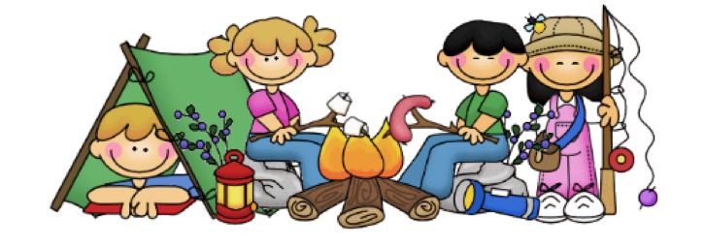

Created : 2024/25

Ratified By Governors: 13/02/25 Review Date: 02/26

**EDUCATIONAL VISITS POLICY**

**1. POLICY STATEMENT**

* 1. At Carhill Integrated Primary School we believe that educational trips and visits are an integral part of school life. They enhance the provision of a broad and balanced curriculum by:
* Providing children with first hand experiences.
* Enhancing learning opportunities.
* Developing personal and social skills.
* Contributing to the development of Thinking Skills & Personal Capabilities.
  1. Visits can include walks around the local area, half or full day visits which require transport and residential visits. All visits must have an educational purpose.

**2. LEGAL CONTEXT**

2.1 The employing authority is legally obliged to ensure that the health and safety of its employees and pupils is safeguarded. This duty is imposed through occupational health and safety statute, specifically under the ‘Health and Safety at Work (N.I.) Order’ 1978, and places responsibility upon employing authorities to ensure that their management arrangements in general, but also those arrangements which encompass specific activities such as educational visits, are adequate to protect the health and safety of all those in any way affected by such employer’s undertakings.

2.2 The manner in which such arrangements are developed is through the process of a risk assessment, the outcome of which acts as the basis for the staff to establish what needs to be put in place to allow the visit to proceed in a way which sufficiently manages the risks to which participants may be exposed.

2.3 The Board of Governors of a school has a statutory duty under Article 7 of the Education and Libraries (NI) Order 2003, to safeguard and promote the welfare of registered pupils at the school at all times when the pupils are in lawful control or charge of a member of staff of the school. The legal framework to protect children from harm is primarily provided by the Children (Northern Ireland) Order 1995 which became law on 4 November 1996 and repeals virtually all pre-existing legislation concerned with child protection.

2.4 At the centre of the Order is that the welfare of the pupil must be the paramount consideration and it is this essential principle which underpins effective practice in the area of child protection. The basic principles of child protection must always be borne in mind when undertaking an educational visit. The pupils’ welfare must always be paramount, and this overrides all other considerations. All pupils have the fundamental right to be protected from harm. Pupils have a right to be heard, to be listened to and to be taken seriously. Careful consideration must be given to pupils who have special educational needs, as such children may be especially vulnerable.

**3. CATEGORIES OF EDUCATIONAL VISITS**

3.1Trips undertaken by the pupils of Carhill Integrated Primary School will not involve an overnight stay and will be in categories 1 and 2 of the E.A. guidelines.

**Category 1:**

Basic This includes visits which take place on a regular basis and occur largely within establishment hours e.g. sporting fixtures, swimming pool visits and outings.

**Category 2:**

One-off day /evening excursions This would include field study trips, theatre visits, business/education visits, regional sporting fixtures. Nature of Educational Visits The school organises a wide range of Educational Visits. These may include:

• Walks around the village.

• Day visits to places of interest to support specific curriculum areas.

**4. BOARD OF GOVERNORS**

4.1 The Board of Governors is responsible for:

* Ensuring that guidance is available to inform the school policy, practices and procedures relating to the health & safety of pupils on educational visits.
* Ensuring that the Principal is supported in matters relating to educational visits and that she has the appropriate time and expertise to fulfil her responsibilities.
* Asking questions about a visit’s educational objectives and how they will be met.
* Ensuring that visits are approved as necessary before bookings are confirmed.
* Ensuring that the Principal has taken all reasonable and practicable measures to include pupils with special educational needs or medical needs on an educational visit.
* Ensuring that they review procedures with the Principal on an annual basis.

**5. THE PRINCIPAL**

5.1 The Principal is responsible for:

* Ensuring approval for visits is given, including liaising with the EA where appropriate.
* Ensuring that the Governing Body is made aware of visits.
* Ensuring that arrangements are in place for the educational objectives of a visit to be inclusive.
* Being aware of the need for best value.
* Ensuring that all accreditation or verification of providers has been met.
* Ensuring that visits are evaluated to inform the operation of future visits.
* Ensuring that each visit has an appropriately competent Group Leader.
* Ensuring that all staff members are aware of the school’s policy and procedures in relation to educational visits.
* Ensuring that the school has an emergency procedure in case of a major incident, which has been discussed and reviewed by staff. This emergency procedure must include getting appropriate support and advice from the EA. (See the school’s Critical Incidents Plan).

**6. GROUP LEADER**

6.1 The Group Leader has overall responsibility for the supervision and conduct of the visit, including direct responsibility for the pupils’ health, safety, and welfare. The Group Leader must:

* Be approved to carry out the visit, suitably competent and knowledgeable about the school’s and EA’s policy and procedures.
* Plan and prepare for the visit and assess the risks.
* Assist in the completion of the risk assessment.
* Define the roles and responsibilities of other staff and pupils and ensure effective supervision of what they do.

6.2 It is the responsibility of the Group Leader& Principal to ensure that emergency arrangements are in place for all Educational Visits. This includes:

* Ensuring that all involved know who the emergency contact is in the school, and in the EA.
* Having access to the Critical Incident Plan.
* Ensuring that parental contact information is up to date and accessible.

**7. VOLUNTEERS**

7.1 Volunteers who are not staff members must:

* Understand and agree the expectations of them.
* Understand their relationship to the pupils, staff and visit leaders.
* Recognise the limits of their responsibility.
* Ensure that they are not left in sole charge of pupils unless this has been formally agreed through a risk assessment.
* Follow instructions from teachers.
* Raise concerns for pupil welfare with the Group Leader.

**8. PLANNING**

8.1 All visits must be approved in advance by the Principal. If possible educational visits should be included in medium-term planning. In some cases it will be necessary to plan further in advance and, where possible, a pre-visit arranged. The information collected should ensure that provision can be made for all children for the whole visit.

**9. EXPLORATORY VISIT**

9.1 An exploratory visit should be made by any teacher who is to lead a group on a residential visit or who is to instruct or lead the group in an outdoor activity in a location that is unfamiliar to them. This will enable the group leader to:

* Ensure at first hand that the venue is suitable to meet the aims and objectives of the school visit.
* Obtain advice from the location manager.
* Assess potential levels of risk.
* Ensure that the venue can cater for the needs of the staff and pupils in the group.
* Become familiar with the area before taking the pupils there.

**10. RISK ASSESSMENT**

10.1 In Carhill Integrated Primary School we undertake a Risk Assessment before every trip. Educational visits cannot be entirely risk-free. The aim, therefore, must be to contain risks within acceptable levels. Care must be taken not to expose the child to unacceptable physical or psychological risk, particularly on those occasions when the educational visit aims to exercise the individual’s sense of adventure.

10.2 Most venues visited by the school are already compliant with Health and Safety regulations. Staff at the venue will be asked to provide evidence that they have undertaken a Risk Assessment and that it is a safe location for the children. If the risks cannot be contained, then the visit must not take place.

The risk assessment should be based on the following considerations:

* What are the hazards?
* Who might be affected by them?
* What safety measures need to be in place to reduce risks to an acceptable level?
* Can the group leader put the safety measures in place?
* What steps will be taken in an emergency?

The person carrying out the risk assessment should record their findings and discuss the safety measures with the Principal before instructing all adults accompanying the children. The children should also be reminded of safety precautions. Other factors to be taken into consideration include:

* The type of visit/activity
* The location, routes and modes of transport
* The competence, experience and qualifications of supervisory staff
* The ratio of teachers/supervisory staff to pupils
* The group members’ age, competence, fitness and temperament and the suitability of the activity
* The special educational or medical needs of pupils
* The quality and suitability of available equipment
* Seasonal conditions, weather and timing
* Emergency procedures
* How to cope when a pupil becomes unable or unwilling to continue
* The need to monitor the risks throughout the visit.

**11. VETTING**

11.1 In the context of educational visits, we follow the school’s Child Protection Policy and procedures. All supervision will be undertaken by staff members who have had a full police check carried out by E.A. Students from Higher Educational Institutes who are on placement in the school and have had appropriate police checks carried out by their training institution may also be supervisors on trips.

11.2 To satisfy staffing ratios, it may be necessary to involve persons other than staff members as volunteers, e.g. parents. These adults can play a very valuable part in ensuring the safety of group participants while on a visit. However, prior to any visit they should be clear about their role and responsibilities during the visit.

**12. COMMUNICATING WITH PARENTS**

12.1 At Carhill Integrated Primary school, we pride ourselves on good communication. This ensures that parents are made aware of the purpose and nature of the visit and will ensure that parents inform the school about any particular needs and issues of their child relevant to the visit.

12.2 Information to parents may include:

* Dates of the visit or series of visits
* Destination details
* Times of departure and return and whether parents will be required to meet their children on return
* The location from where the pupils will be collected and returned
* Mode(s) of travel including the name of any travel company
* Information regarding lunch and/or spending money (where relevant)
* Cost of the trip. Teachers will inform the Principal if a child seems to be unable to meet the payment, so that appropriate pastoral arrangements can be made.

**13. PARENTAL CONSENT**

13.1 Parental consent must be obtained for all educational visits. This will be done for each visit or outing. Class Dojo can be used to collect parental consent.

**14. PREPARATION CHECKLIST FOR STAFF**

* Check school diary to ensure the date is suitable.
* Book the venue.
* Provide Secretary with date and venue (including telephone number).
* Ask Secretary to book transport and inform school meals kitchen.
* Contact parents, informing them of venue, date, times, appropriate clothing, lunches and any costs.
* Send and collect any permission details

**15. GROUP LEADER**

15.1 One teacher, the group leader, should have overall responsibility for supervision during the visit and should have regard to the health and safety of the group. The leader should clearly define each group supervisor’s role and ensure all tasks have been assigned. She should also ensure that adequate first-aid provision will be available.

15.2 The group leader should make it clear to pupils that they must:

* Not take unnecessary risks
* Follow the instructions of the leader and other supervisors, including those at the venue
* Dress and behave sensibly and responsibly.

**16. CHILD: ADULT RATIOS**

16.1 Ratio of adults to children should be at least:

* 1:10 in Foundation Stage
* 1:15 in Key Stages 1 & 2.

The number of adults needed will depend on the nature of the visit and the amount of supervision needed.

**17. TRANSPORT**

17.1 The school must be satisfied that all the transport arrangements meet the legal statutory requirements for the type of journey proposed. Only companies approved by E.A. will supply transport. The transport selected must provide each child with a single seat and while in a bus, taxi or car the child must be protected by a seat belt.

17.2 Pupils using transport on a visit should be made aware of rules:

• Do not rush towards the transport when it arrives.

• Wear your seatbelt and stay seated whilst travelling.

• After leaving the vehicle, wait for it to move off before moving.

• Do not cross the road unless accompanied by a teacher or supervisor.

• If you feel unwell, tell a teacher or supervisor.

**18. PRIOR TO THE VISIT**

18.1 All staff will be made aware of the Educational Visits Checklist (Appendix A) and the Educational Visits Record Grid (Appendix B). The group leader must ensure that an Educational Record Grid and a Risk Assessment are completed prior to the trip. All staff must also have a list of all names of the children on the trip. They must also check that there are Health Plans/Medicines for those children who may require them, in accordance with the school’s First Aid and Administration of Medication Policies.

**19. CHECKLIST OF ITEMS TO TAKE**

* Emergency contact list
* Plastic bags
* Portable First Aid Kit
* Individual pupil medical supplies, such as inhalers
* Any resources or equipment needed
* Cheque(s) to pay for costs (if appropriate)
* List of pupils’ names

**20. DURING THE VISIT:**

20.1 Children should be always within the sight of a supervisor. Class groupings should stay together except where the venue requires them to break into smaller groups. Supervisors should be aware of any dietary requirements or medical/ physical needs of any of the children in their group.

20.2 In the event of a child needing significant medical attention whilst on the trip or travelling to/ from a trip, the school will be contacted as soon as possible after assistance has been given or help has been requested. On returning to school the supervisor should remain with the child until he/she has been collected by an adult or in the case of older children a check has been made to ensure that the correct procedures for going home are being followed.

**21. HEAD COUNTS**

21.1 Whatever the length and nature of the visit, regular head counting of pupils should take place, particularly before leaving any venue. All supervisors should carry a list of all pupils and adults involved in the visit at all times. Pupils should be easily identifiable, especially if the visit is to a densely populated area. School uniform will be worn to help identify group members more easily. Pupils should not wear name badges. The group leader should establish rendezvous points and tell pupils what to do if they become separated from the group.

22. Reporting back on return to school

22.1 The Group Leader should report back to the Principal on return to school and provide a brief account of the trip. Any incidents, accidents or injuries that have occurred should be reported. Accidents, injuries, or incidents should be recorded in the School Accident Book (staffroom) or on an Incident Form (Principal’s office).

22.2 The Principal will advise regarding any further action to be taken with reference to either accidents and/or incidents which occurred on a trip

**23. CRITICAL INCIDENTS**

23.1 A critical incident may be defined as any sudden and unexpected incident or sequence of events which causes trauma within a school community, and which overwhelms the normal coping mechanisms of that school. In the event of a critical incident occurring during a school visit the school’s Critical Incident Management plan will be implemented.

**APPENDIX A**

**CARHILL INTEGRATED PRIMARY SCHOOL PLANNING CHECKLIST FORM**

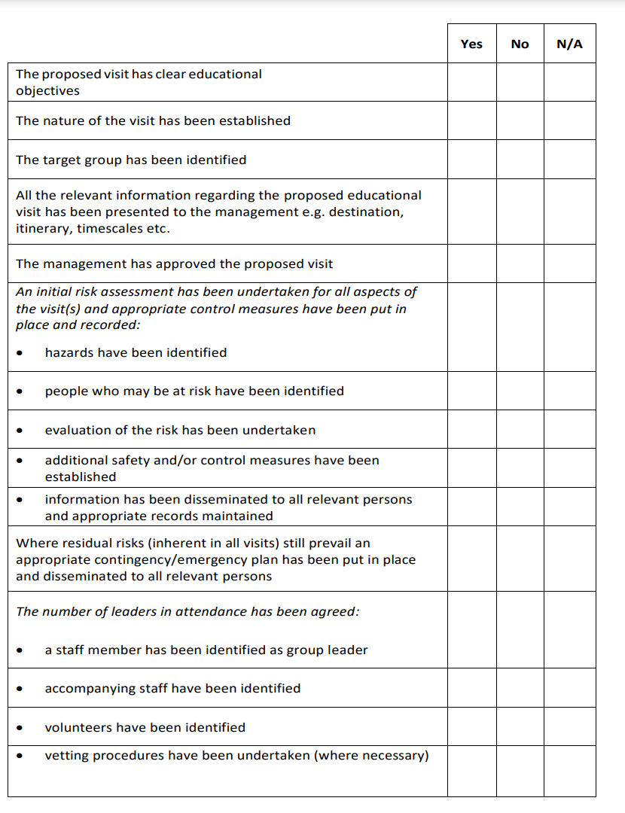

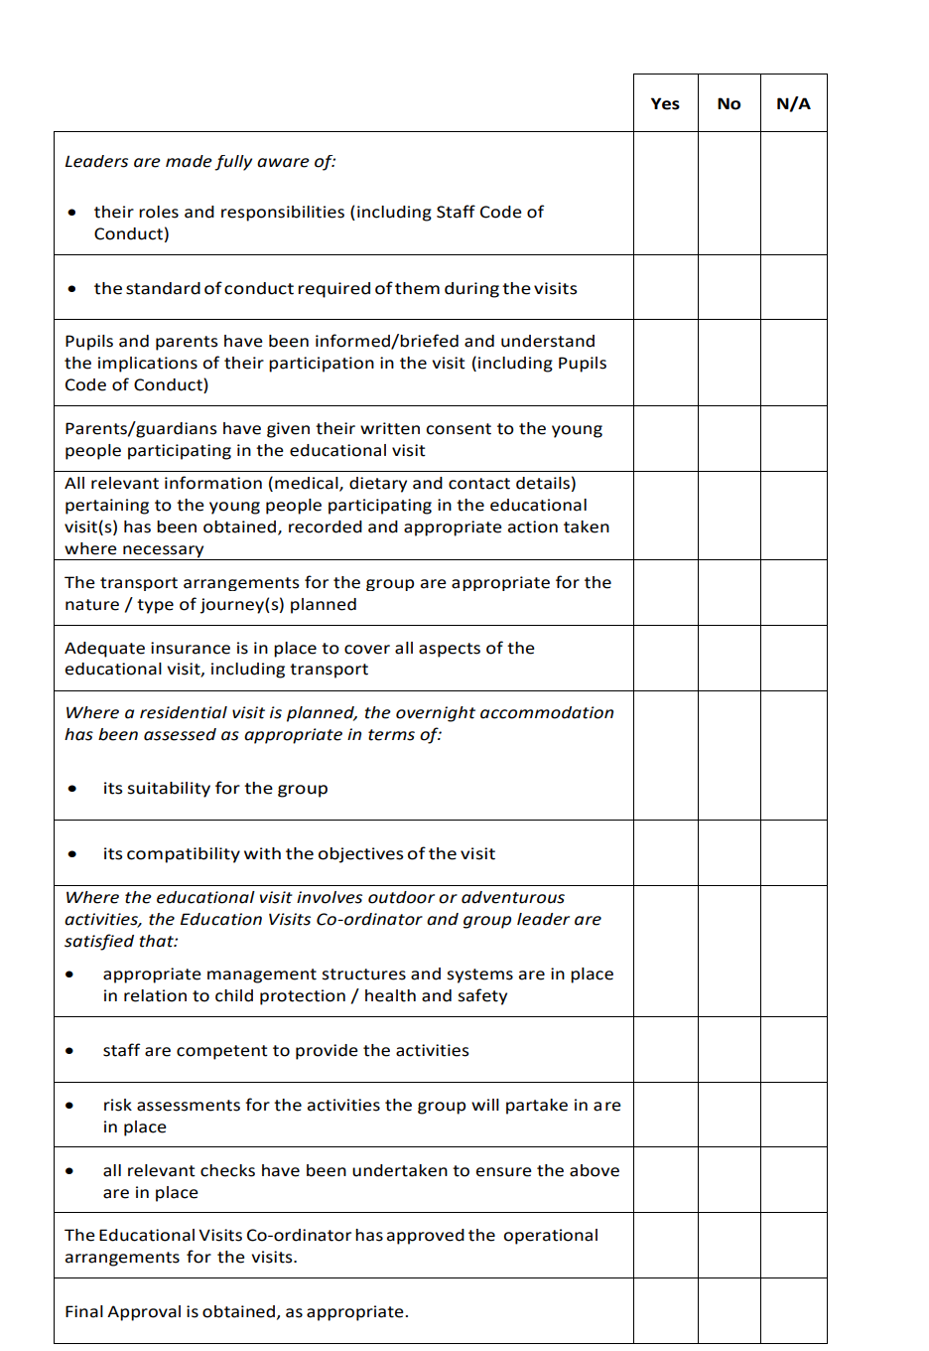

**APPENDIX B**

**CARHILL INTEGRATED PRIMARY SCHOOL EDUCATIONAL VISITS CHECKLIST**



